EXERCISE 5
- List all employees who hold the titles of “Senior Programmer” and “Multimedia Programmer”.
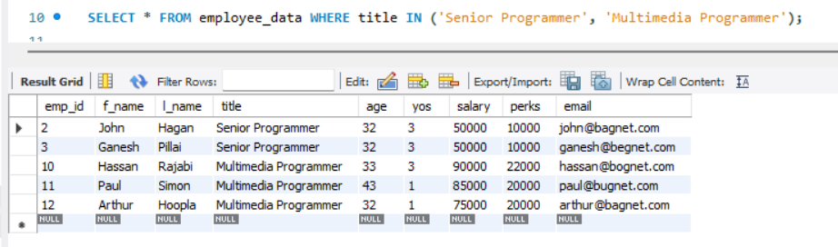
- List all employee names with salaries for employees who draw between $70000 and $90000.
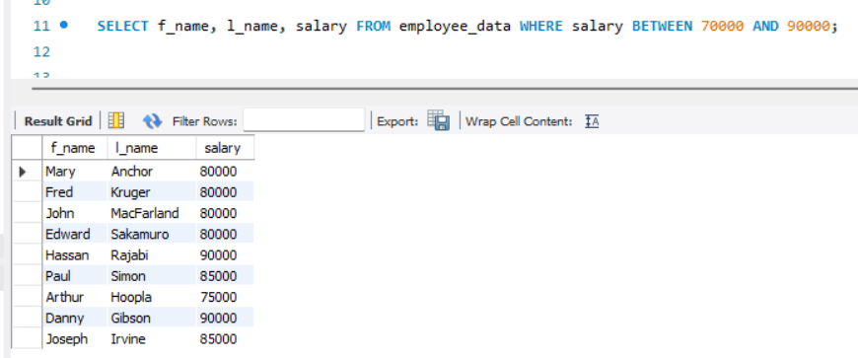
- What will the following statement display?
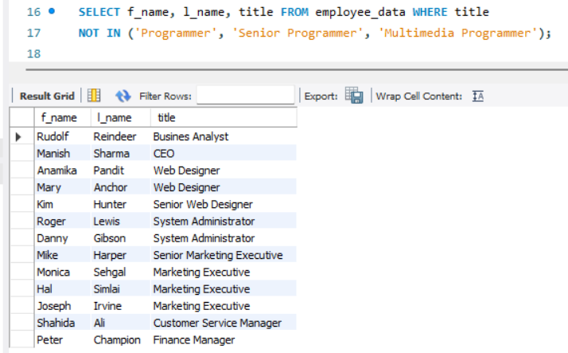

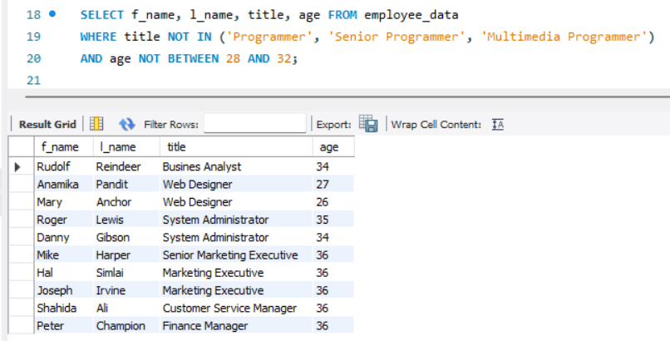
- Here is a more complex statement that combines both BETWEEN and IN. What will it display?

